**LIBRARY MANAGEMENT SYSTEM**

**Overview:**

* This is a Library Management System, where user can add books to cart and then checkout. There is a section called pastborrows where books taken and the status is shown as if the book is returned or not.
* Admin can change that status whether returned or not from his/her login.
* I have used a fake json server and added all the required date in db.json file.
* I have added an auth guard so no one can go to random page without logging in. It stays on the search page because anyone can search for books and see what are available without logging in.
* Both Admin and User can search for books and see what all are available without logging in.

**Screenshots:**

Before logging in

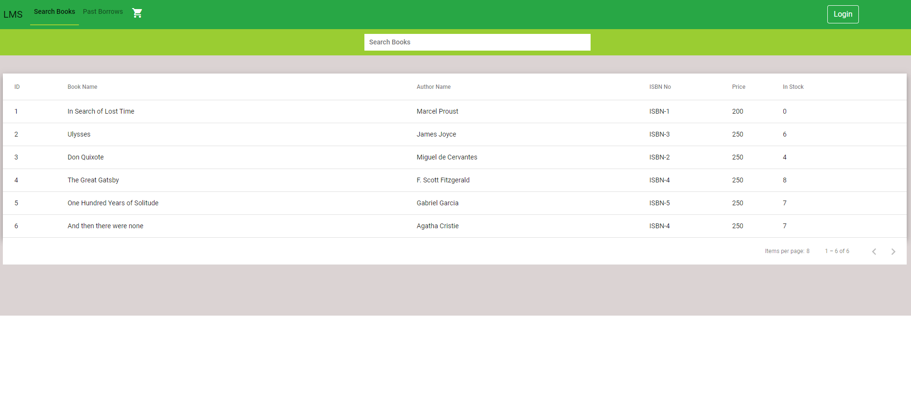

Searching for a book

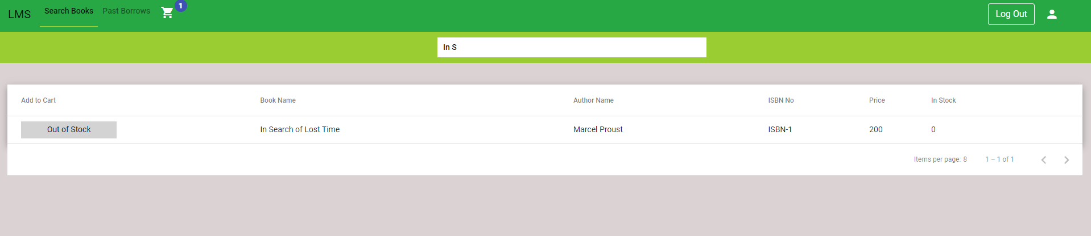

Logged in as a user. We can see add option now

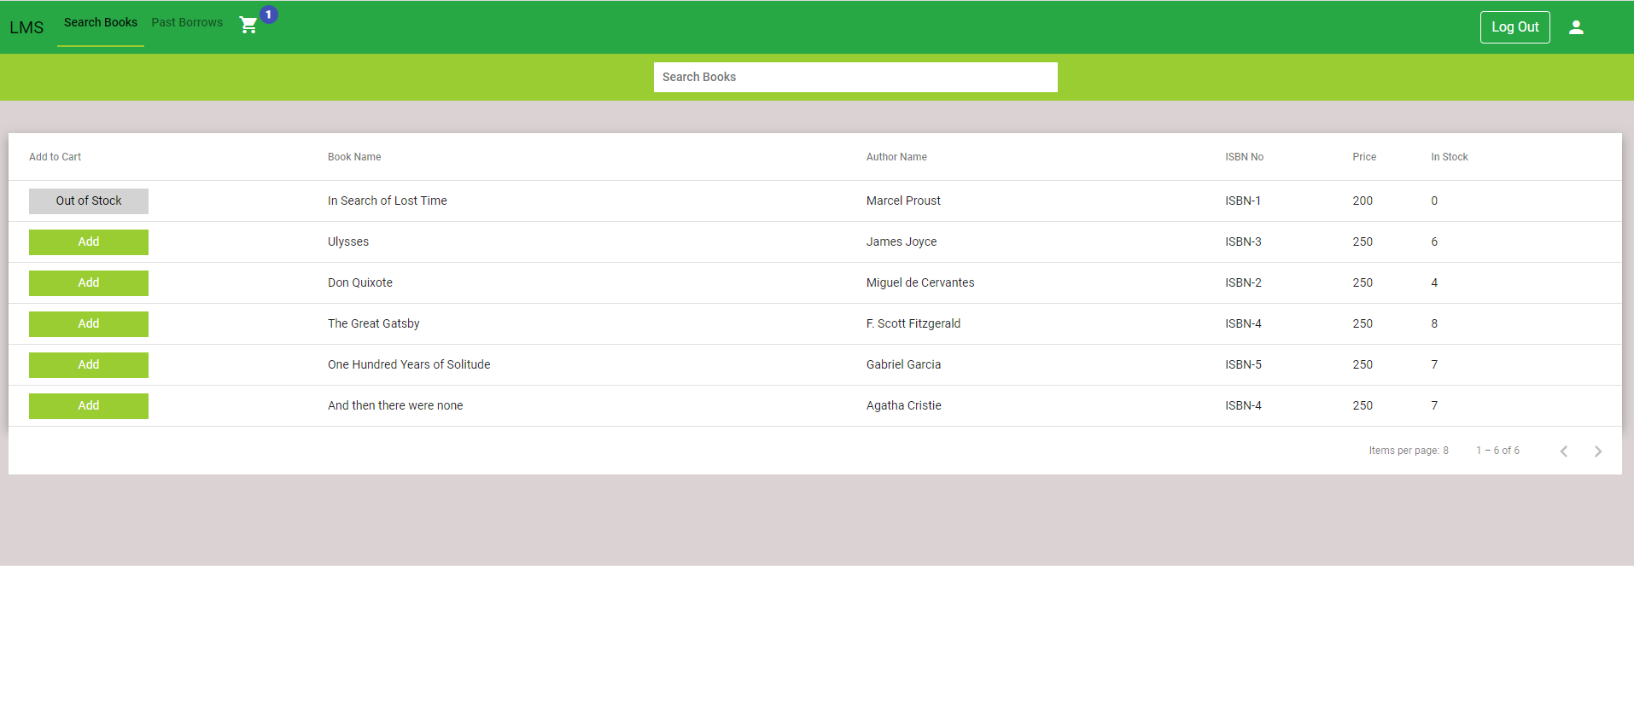

In the past borrows we see what all we have taken before. See now everything is on return status.

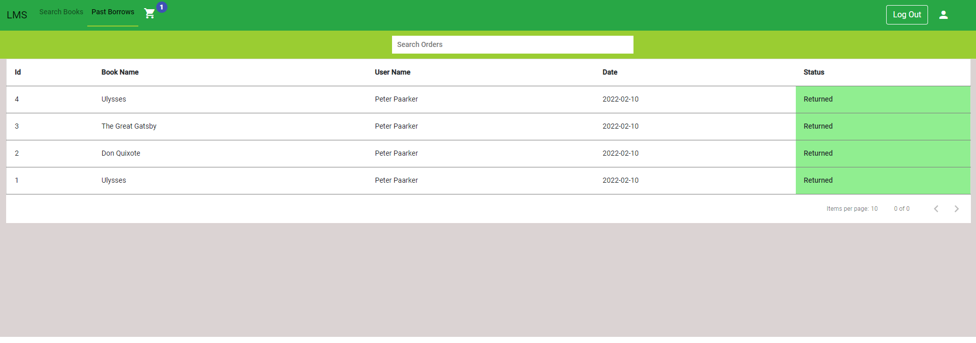

I will add a new book to the cart now and check out. As we can see a book with not returned status have been added.

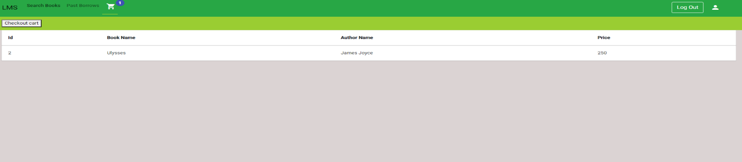

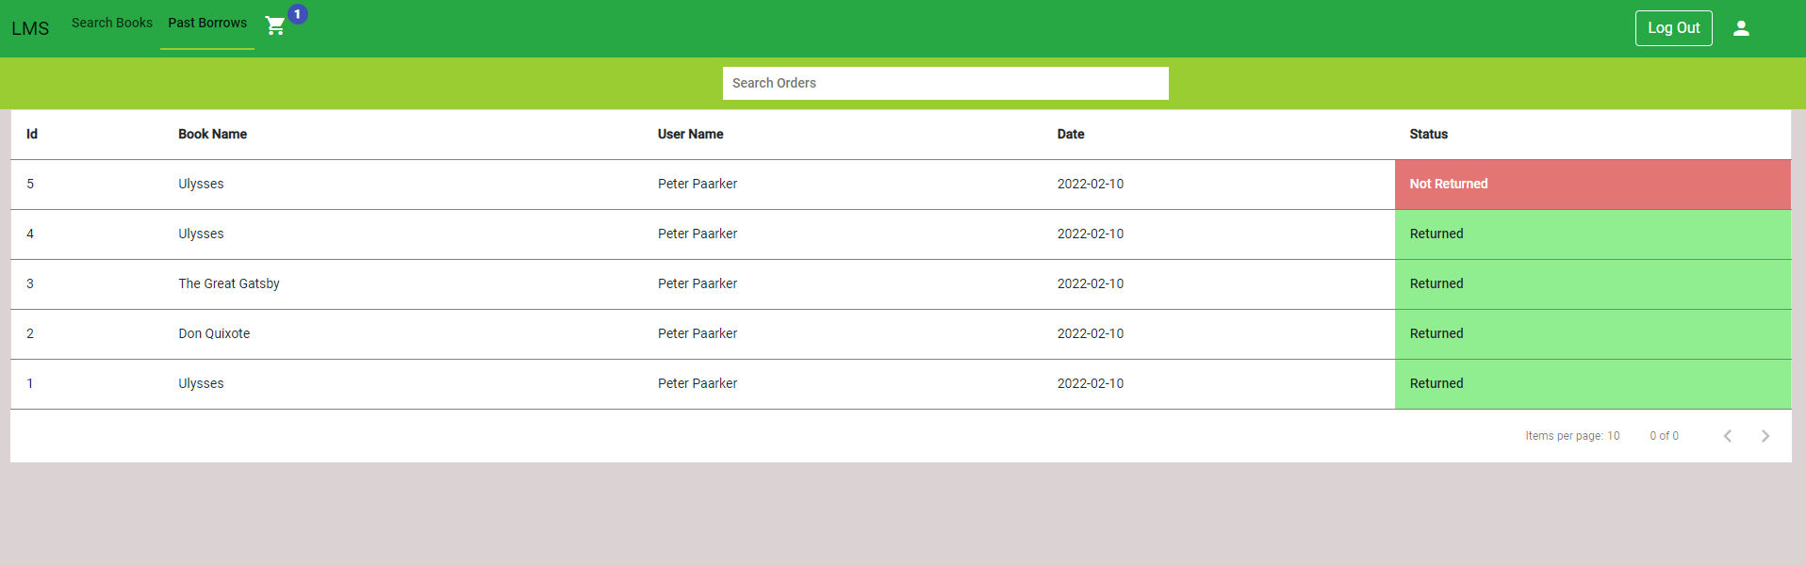

Now I am logged in as an admin. As you can see there is no add button here like there was in the user one.

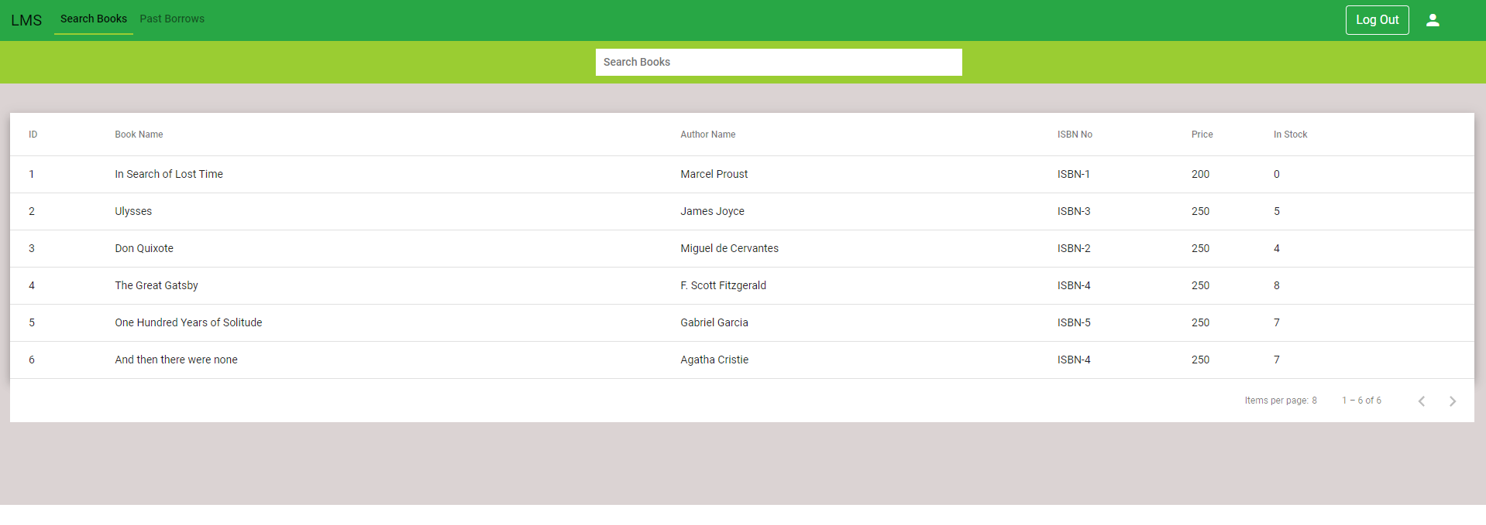

We can see admin has a return button and when clicked its status changes and tick appears. User does not have this because only admin can change the status only when the book is returned to him.

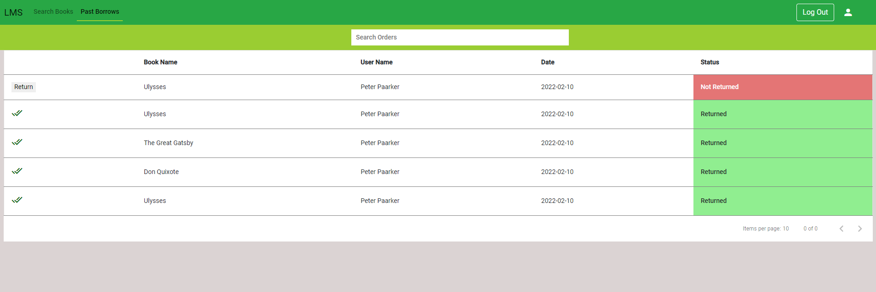

Now the status is changed

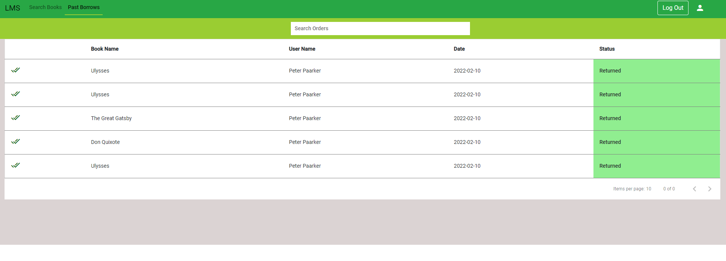

This is user one and when I clicked return on admin, it changes on user part too.

